**19.1.1**

Good morning people

Good morning, Todd!

How are you? The Big Boss and I don't like the clothes you wear to work

You don't like us clothes?

What wrong with my clothes?

This is a business, and peolple need wear business clothes. Look at my suit! this is what people wear to work. **A T-shirt, is not OK to wear to work**

This is a fine T-shirt

A T-shirt is good wear to the part, or the gym, but not to work

What can we wear to work now?

Thank you for the question, Aanya! here is a list of the clothes you can wear to work now. Starting tomorrow, **you can not wear jeans**

No jeans? Can we wear nice jean?

You can't wear jeans, no nice jeans, no old jeans, no new jeans, no jeans period. No T-shirt. **No one can wear a hat to work**

I don't have hair

I'm sorry, but no hat

What?

**No tennis shoes or trainers,** you have to wear nice shoes. Oh, **eveyone has to wear socks**. What's that?

It’s sweater

**No sweater or jumper at work!**

Can I wear dress?

**Women can wear nice a dress or a skirt**

**Can I wear pants?**

**Yes, men and women can wear a nice trousers**

**Is my top OK?**

Yes, that top is OK. **Men have to wear suits or jackets and ties**

I have to wear a tie?

Yes, this is a business, business man wear suite and tie. Look at the Big Boss, he wears suit

Why do we have to wear those clothes?

Because, I said so

What is it, Khea?

Can we wear toilet paper on the shoes?

What?... Be quite!

No, to work

There are many people on a little sofa. I like working with my friends on the weekend. Is watching TV work? LOL

This was fun, I like working at home because we can wear jean and T-shirts #Todd is not cool

Next time we work at your apartment, Marco has to wear a suit and tie Isn't that right #Marco

What are the people taling about?

* Clothes

Todd doesn’t like the employees’s clothes

No one can wear hats to work

The employees have to wear nice shoes and socks to work

Who has to wear suits or jacket?

* Men

I’m wearing a hat because it’s cold outside

I like your dress. Is it new?

I’m sorry. You can’t wear a sweater to work

The employees are wearing tops

I like those socks. How much do they cost?

The employees have to wear nice pants to work

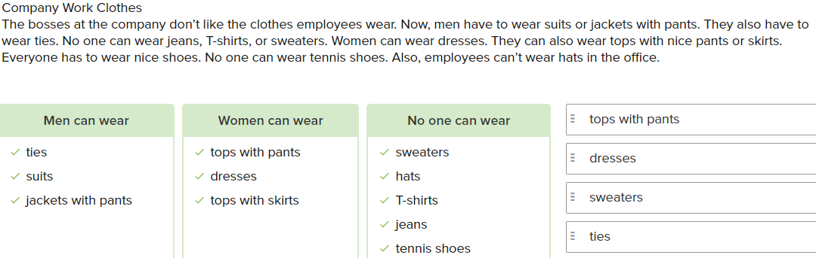

**Conversation**

I wasn't at the meeting yesterday. What was said about?

It was about employee clothes

Ok. What can employee wear?

Men have to wear suit or jacket and tie

Anh what can women wear?

They can wear dress

Can women wear pants?

Yes, they can wear top and nice pants

Can we wear jean?

No, no one can wear jeans. And you can't wear T-shirt or sweater

I undertand, and what about shose?

You can't wear tennis shoes

OK, thank you, see you tomorrow

See you tomorrow. And don't wear jeans and a sweater to work!

**Exercise**

The boss says we can’t wear shoes without socks.

I like your suit and tie.

When it’s cold, I wear a warm hat on my head.

You can’t wear jeans to work. You have to wear nice pants.

Tom: What can men wear to work?

* They can wear suits or jackets and ties.

Jill: Can we wear nice jeans to work?

* No. No nice jeans, old jeans, or new jeans.

Are these pants OK to wear?

* Boss: Yes, they are. They’re fine.

Vicky: Is my top OK?

* Yes, it’s fine.

**19.1.2**

There are many people on a little sofa. I like working with my friends on the weekend. Is watching TV work? LOL

This was fun, I like working at home because we can wear jean and T-shirts #Todd is not cool

Next time we work at your apartment, Marco has to wear a suit and tie Isn't that right #Marco

What do Khae and Aanya write about?

* A photo

In the photo, they are sitting **on a sofa**.

The people on the sofa are **watching TV**.

Why does Khae like working from home?

* Because she doesn’t have to wear business clothes.

Where were the people?

* In an apartment.

Why can’t we wear jeans to work? I hate the boss. #SheIsNotNice

Look at this photo. Do you like my new T-shirt, @Susan?

This was a fun day at the beach. Wasn’t it,@Jerry?

I start a new job tomorrow. #IamALittleScared

Who is in this photo with you,@Jenny?

**Skills Practice**

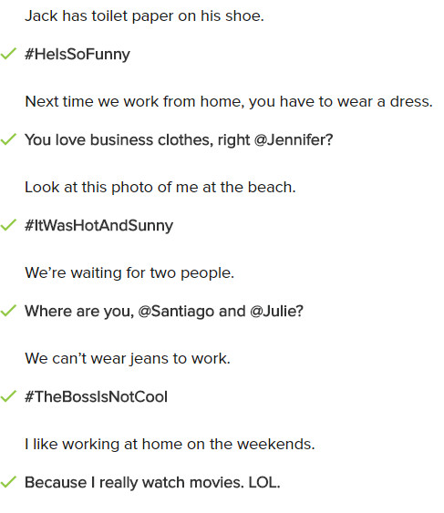

**Conversation**

Look at this photo.

That’s funny. Someone is sleeping at work.

Let’s put the photo online and write something about it.

Ok. Let’s write, “An employee sleeps at work”

Good idea.Now let’s write a hashtag(#).

Ok. How about “# very tired”

Great. Look at the funny hat. It’s perfect for Aanya. Let’s put it online.

Ok. Let’s write, “, This hat is perfect for you@Aanya”

Let’s tell her to wear it to work.

Ok. Let’s write. “Why don’t you wear this hat to work @Aanya”

Ok. Do you want to hashtag(#)?

**Exercise**

I don’t have to wear a suit when I work at home.#WorkIsGood

I like watching TV with my friends. # LoveThisSofa.

Next time we watch movies, no one eats popcorn. Isn’t that right, @Ed?

The beach was beautiful!#SunnyDay.

Is watching TV work?#NoItIsNot.

Look at my funny hat.LOL

We need to take a break. Isn’t that right, @Wendy?

This sofa is small. Isn’t that right, @Aran?

**19.1.3**

I don’t think so, Aanya . No suit and tie for me, please. @Aanya and @Khae do you like Todd’s suit from this morning?

Marco is very funny. He is people need to see his.

I want you have a donuts

You do?

Yes, take it

Thank you

What are Khae's and Aanya's messages about?

* Working at home

What does Marco say about Aanya's online message?

* He doesn't want to wear work clothes in Khae's apartment

Marco puts a photo of Todd online

Who thinks Marco is funny?

* Khae and Aanya

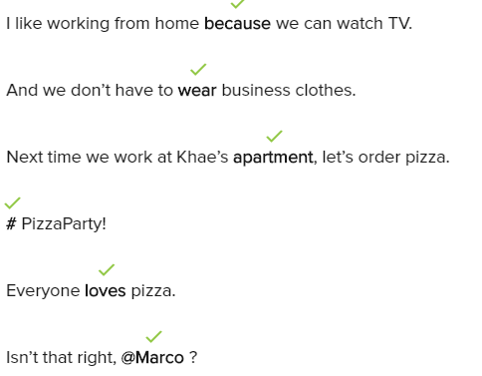

**Skills Practice**

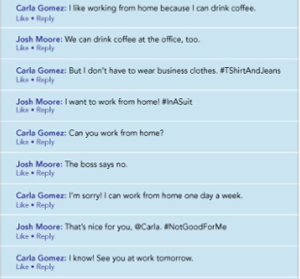

Who can drink coffee?

* Carla and Josh

Who is wearing a T-shirt and jeans?

* Carla

Who can’t work from home?

* Josh

How many days can Carla work from home a week?

* 1

Who is working in the office tomorrow?

* Carla and Josh

**Conversation**

Let’s look at these messages about work. What’s the first one?

It’s about our boss. John says our boss is terrible and he hates work

Oh. No what does the next message say?

Hailey says John is great . She also says we can’t drink coffee at our desks.

What does her hashtag say?  
It says I need coffee.

Look at the photo Mia put online.

That’s funny . It’s our boss with coffee and donuts.

Let’s write something about the photo.

Ok. Let’s write “We want to eat at our desks. #TheBossIsNotNice

**Exercise**

What is the best hashtag for this online post?

* Jack Morgan: I like working from hơm because I can work and eat.#GoodDonuts!

What is the best message for this postcard?

* It’s sunny and hot here . I’m having a great time on vacation.

What is the best message for this online photo?

* I love working at home #NoSuitAndTieForMe

What is the best response for this online message?

* Jorge : I’m happy it’s Friday. Me too! Do you want go to a movie tomorrow?

What is the best hashtag for this online post?

* Kate: I like working from home and watching TV.#AlwaysWorkFromHome.

What is the best message for this postcard?

* This place is amazing and beautiful. I can see a lot of cool things.

What is the best message for this online photo?

* You look great, @Dan. #ClothesMakeTheMan.